**Prodigy InfoTech Internship**

**Task 4**

Analyze and visualize sentiment patterns in social media data to understand public opinion and attitudes towards specific topics or brands.

* **Understanding the Shape of Data**

* **Data Cleaning**

* **Data Exploration**

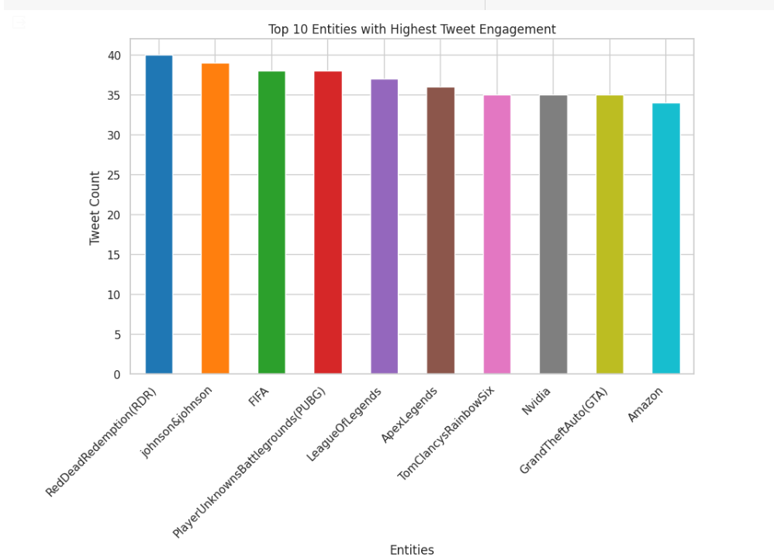

* **Exploratory Data Analysis(EDA)**

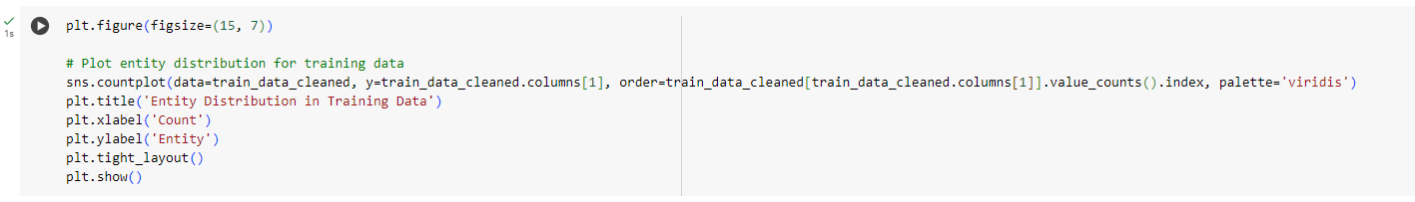

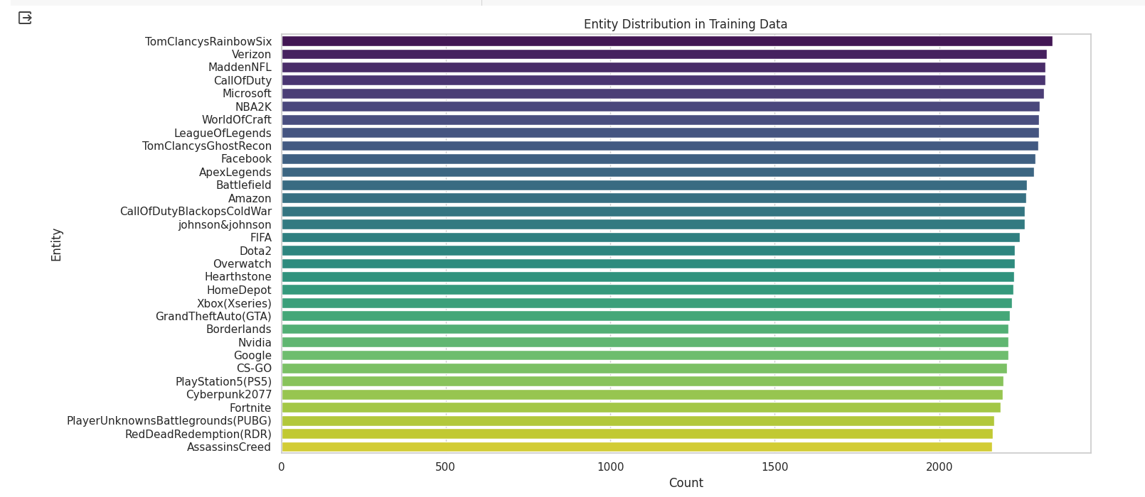

* **Building Basic Model & Testing:**

